Kullanici Ekle/Degistir
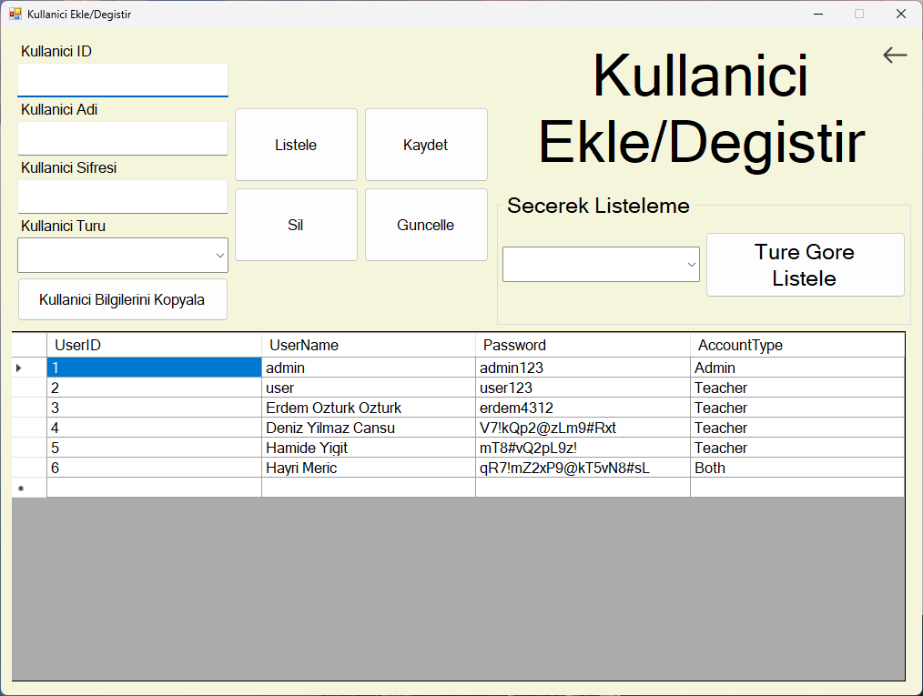
using System;
using System.Collections.Generic;
using System.ComponentModel;
using System.Data;
using System.Data.OleDb;
using System.Drawing;
using System.Linq;
using System.Text;
using System.Threading.Tasks;
using System.Windows.Forms;

namespace OgrenciBilgiSistemi
{
public partial class kullaniciEkDeg : Form
{
public kullaniciEkDeg()
{
InitializeComponent();
}

private void listeleBtn_Click(object sender, EventArgs e)
{
Methods.DbList.ListDb("users", usersDBGrid);
}

private async Task giveAlert()
{
System.Media.SystemSounds.Exclamation.Play();
infoCopyBtn.Text = "Kopyalandi";
await Task.Delay(1000);
infoCopyBtn.Text = "Kullanici Bilgilerini Kopyala";
}

private async void infoCopyBtn_Click(object sender, EventArgs e)
{
if (!string.IsNullOrEmpty(usernameEntry.Text) ||
!string.IsNullOrEmpty(userPasswordEntry.Text) ||
!string.IsNullOrEmpty(accountTypeSelect.Text))
{
Clipboard.SetText($"{usernameEntry.Text} {userPasswordEntry.Text} {accountTypeSelect.Text}");
await giveAlert();
}
else
{
MessageBox.Show("Eksik bilgi oldugu icin kopyalanamadi.", "Bilgilendirme", MessageBoxButtons.OK,
MessageBoxIcon.Information);
}
}

private void kaydetBtn_Click(object sender, EventArgs e)
{
string chosenAccType = accountTypeSelect.Text;
if (chosenAccType == "Yonetici")
{
chosenAccType = "Admin";
}
else if (chosenAccType == "Ogretmen")
{
chosenAccType = "Teacher";
}
else if (chosenAccType == "Ikiside")
{
chosenAccType = "Both";
}
else
{
MessageBox.Show("Yanlis hesap tur secimi.", "Bilgilendirme", MessageBoxButtons.OK);
}
Methods.DbConn.DbConnectionOpen("users");
OleDbCommand cmd = new OleDbCommand("INSERT INTO Users ([UserName], [Password], [AccountType]) " +
"VALUES (@p1, @p2, @p3)", Variables.DbConn.UserConn);
cmd.Parameters.AddWithValue("@p1", usernameEntry.Text);
cmd.Parameters.AddWithValue("@p2", userPasswordEntry.Text);
cmd.Parameters.AddWithValue("@p3", chosenAccType);
cmd.ExecuteNonQuery();
MessageBox.Show("Basariyla kaydedildi.", "Bilgilendirme", MessageBoxButtons.OK);
Methods.DbConn.DbConnectionClose("users");
Methods.DbList.ListDb("users", usersDBGrid);
}

private void backBtnUser_Click(object sender, EventArgs e)
{
Methods.FormSwitching.FormSwitch(this, new MainPage());
this.Close();
}

private void kullaniciEkDeg_Shown(object sender, EventArgs e)
{
Methods.DbList.ListDb("users", usersDBGrid);
}

private void usersDBGrid_CellContentClick(object sender, DataGridViewCellEventArgs e)
{
int secilen = usersDBGrid.SelectedCells[0].RowIndex;
userIDEntry.Text = usersDBGrid.Rows[secilen].Cells[0].Value.ToString();
usernameEntry.Text = usersDBGrid.Rows[secilen].Cells[1].Value.ToString();
userPasswordEntry.Text = usersDBGrid.Rows[secilen].Cells[2].Value.ToString();
accountTypeSelect.Text = usersDBGrid.Rows[secilen].Cells[3].Value.ToString();
}

private void byTypeBtn_Click(object sender, EventArgs e)
{
string chosenAccType = listSelectionBox.Text;
if (chosenAccType == "Yonetici")
{
chosenAccType = "Admin";
}
else if (chosenAccType == "Ogretmen")
{
chosenAccType = "Teacher";
}
else if (chosenAccType == "Ikiside")
{
chosenAccType = "Both";
}
else
{
MessageBox.Show("Yanlis hesap tur secimi.", "Bilgilendirme", MessageBoxButtons.OK);
}
DataTable dataTable = new DataTable();
OleDbDataAdapter dataAdapter = new OleDbDataAdapter($"Select * from Users " +
$"WHERE AccountType='{chosenAccType}'",
Variables.DbConn.UserConn);
dataAdapter.Fill(dataTable);
usersDBGrid.DataSource = dataTable;
}

private void silBtn_Click(object sender, EventArgs e)
{
Methods.DbConn.DbConnectionOpen("users");
OleDbCommand cmd = new OleDbCommand("DELETE FROM Users WHERE UserID = ?", Variables.DbConn.UserConn);
cmd.Parameters.AddWithValue("?", Convert.ToInt32(userIDEntry.Text));
cmd.ExecuteNonQuery();
MessageBox.Show("Basariyla silindi.", "Bilgilendirme", MessageBoxButtons.OK);
Methods.DbConn.DbConnectionClose("users");
Methods.DbList.ListDb("users", usersDBGrid);
}

private void guncelleBtn_Click(object sender, EventArgs e)
{
string chosenAccType = accountTypeSelect.Text;
if (chosenAccType == "Yonetici")
{
chosenAccType = "Admin";
}
else if (chosenAccType == "Ogretmen")
{
chosenAccType = "Teacher";
}
else if (chosenAccType == "Ikiside")
{
chosenAccType = "Both";
}
else
{
MessageBox.Show("Yanlis hesap tur secimi.", "Bilgilendirme", MessageBoxButtons.OK);
}
Methods.DbConn.DbConnectionOpen("users");
OleDbCommand cmd = new OleDbCommand("UPDATE Users set [UserName]=@p1, [Password]=@p2, " +
"AccountType=@p3 WHERE UserID=@p4", Variables.DbConn.UserConn);
cmd.Parameters.AddWithValue("@p1", usernameEntry.Text);
cmd.Parameters.AddWithValue("@p2", userPasswordEntry.Text);
cmd.Parameters.AddWithValue("@p3", chosenAccType);
cmd.Parameters.AddWithValue("@p4", Convert.ToInt32(userIDEntry.Text));
cmd.ExecuteNonQuery();
MessageBox.Show("Basariyla guncellendi.", "Bilgilendirme", MessageBoxButtons.OK);
Methods.DbConn.DbConnectionClose("users");
Methods.DbList.ListDb("users", usersDBGrid);
}
}
}

